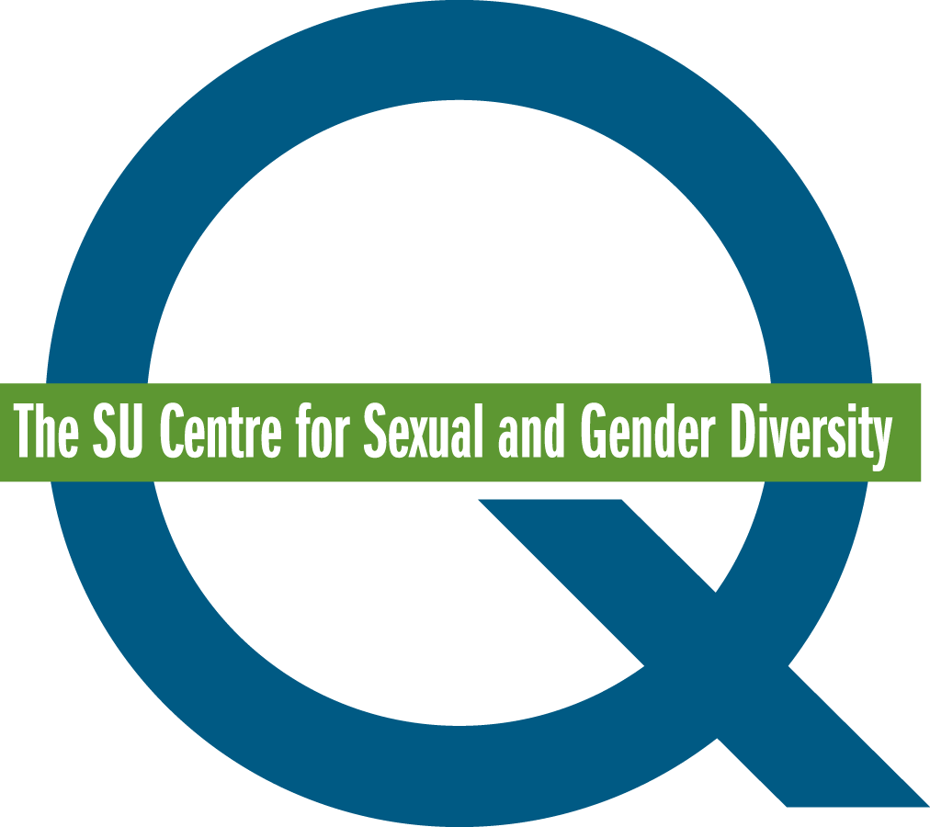

Queer Mentoring Mentee Application Form

The Q Centre’s Queer Mentoring initiative strives to provide sexual and gender minority undergraduate students with opportunities to empower themselves by pairing them with established, queer-identified role models (ie. graduate students, and staff and faculty members). The mentees will work with their mentors to set, and work towards, professional and social goals. These include goals related to coming out, identity, networking, friendship, dating, volunteering, working, other extracurricular activities, stress, relationship issues, and health and wellness.

The program takes place during the Fall/Winter semesters of the academic year. Mentees must be registered as full-time undergraduate students at the University of Calgary. Their minimum time commitment is 7 hours.

If you are interested in applying to be a mentee, please fill out the application and email it to
qcentre@ucalgary.ca.

Name
Preferred Pronouns
Telephone Number
Email Address
Program
Year of Study
UCID Number
Why does this program interest you?

What types of goals would you like to work on (This information will be used to pair Queer Mentees and Mentors)?

What are you looking for in a mentor?

Are you able to contribute at least 7 hours to the program?

Thank you for taking the time to apply for the Queer Mentoring Program!

Please note that not all applicants may be accepted to the program. Acceptance to the program may be determined by the number and match suitability of mentor and mentee applicants.

