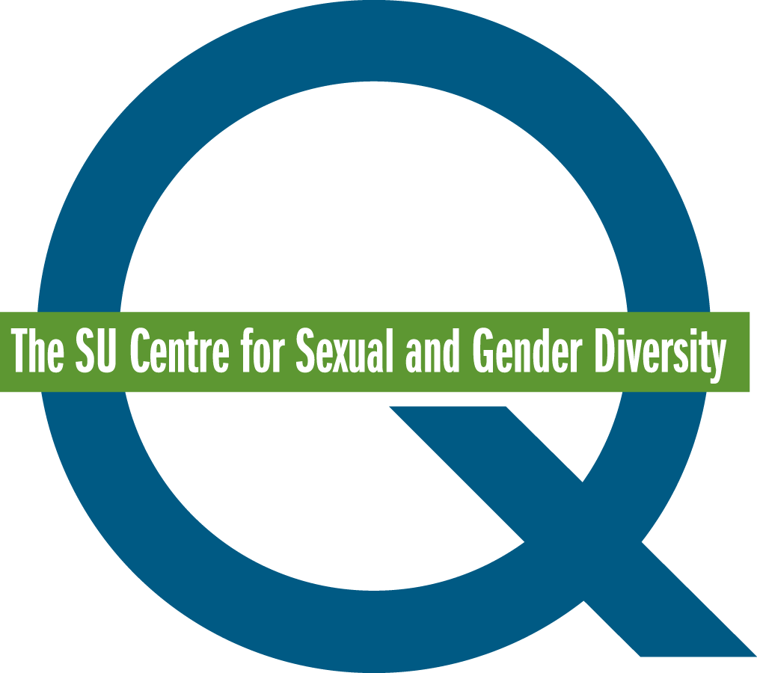

**Queer Mentoring Mentee Application Form**

The Q Centre's Queer Mentoring Program aims to support undergraduate students who are part of sexual and gender minority communities by connecting them with experienced queer-identified mentors. These mentors include graduate students, faculty, and staff members from the University of Calgary. Through this mentorship, mentees will have the opportunity to set and work toward both professional and personal goals, with their mentors' guidance.

Areas of focus may include, but are not limited to:

* Navigating coming out and identity exploration
* Building a network of connections (academic, social, and professional)
* Forming friendships and relationships, including dating
* Engaging in volunteering or extracurricular activities
* Managing stress and addressing mental health and wellness
* Working through relationship issues

The program runs during the Fall and Winter semesters. Mentees are required to be full-time undergraduate students at the University of Calgary and must commit to a minimum of 7 hours throughout the program.

If you are interested in applying to be a **mentee,** please fill out the application and email it to **qcentre@ucalgary.ca**.

|  |  |
| --- | --- |
| Name |  |
| Preferred Pronouns |  |
| Telephone Number |  |
| Email Address |  |
| Program |  |
| Year of Study |  |
| UCID Number |  |
| Why does this program interest you? |  |
| What types of goals would you like to work on? (This information will be used to pair Queer Mentees and Mentors) |  |
| What are you looking for in a mentor? |  |
| Are you able to contribute at least 7 hours to the program? |  |

**Thank you for taking the time to apply for the Queer Mentoring Program!**

Please note that not all applicants may be accepted to the program. Acceptance to the program may be determined by the number and match suitability of mentor and mentee applicants.